**Decision Support System For Food Processing Industry**

Submitted in partial fulfillment of there requirements

of the degree of

**B. E. Computer Engineering**

By

**Dilipkumar Prajapati 112095**

**Rupesh Surve 122274**

Supervisor(s):

**Mrs. Bidisha Roy**

Associate Professor



Department of Computer Engineering

St. Francis Institute of Technology

(Engineering College)

University of Mumbai

2014-2015

**CERTIFICATE**

This is to certify that the project entitled **“Decision Support System For Food Processing Industry ”** is a bonafide work of **“Rupesh Surve” (122274) and “Dilipkumar Prajapati” (112095)** submitted to the University of Mumbai in partial fulfillment of the requirement for the award of the degree of B.E. in Computer Engineering.

**Mrs. Bidisha Roy Dr. A. K. Sen**  **Guide Principal Head of Department**

**Project Report Approval for B.E.**

This project report entitled “**Decision Support System For Food Processing Industry”**

by **Dilipkumar Prajapati (112095)** and **Rupesh Surve (122274)** is approved for the degree of ***B.E. in Computer Engineering.***

Examiners

1.---------------------------------------------

2.---------------------------------------------

Date:

Place:

Declaration

We declare that this written submission represents our ideas in our own words and where others' ideas or words have been included, We have adequately cited and referenced the original sources. We also declare that we have adhered to all principles of academic honesty and integrity and have not misrepresented or fabricated or falsified any idea/data/fact/source in our submission. We understand that any violation of the above will be cause for disciplinary action by the Institute and can also evoke penal action from the sources which have thus not been properly cited or from whom proper permission has not been taken when needed.

-----------------------------------------

(Signature)

-----------------------------------------

(Name of student and Roll No.)

----------------------------------------

(Signature)

-----------------------------------------

(Name of student and Roll No.)

Date:

iii

**Abstract**

The Decision Support System (DSS) is one of the information system applications that can assist the decision making process of management by providing timely and efficient solutions. DSS provides a user friendly interface to the non-technical decision makers so they can construct management solutions in the shortest timeframe. In the food warehouse, inventory information is needed throughout the whole duration of operations so as to minimize the inventory loss caused by Deterioration of Foods. The aim of this project is to provide an Integrative Food Handling System (IFHS) for managing inventory information in Food Warehouses. It is an Inventory Information Management System, which contains a Notification Mechanism, facilities allocation and stock picking decision support system. The notification mechanism can help to control the variations of the storage environment by informing staff when variations occur. The decision support system can help minimize loss of inventory caused by deterioration, contamination and expiry.

iv

**Contents**

|  |  |  |
| --- | --- | --- |
| **Chapter** | **Contents** | **Page No.** |
| **1** | **INTRODUCTION:** |  |
|  | **1.1 Description** |  |
|  | **1.2 Problem Formulation** |  |
|  | **1.3 Motivation** |  |
|  | **1.3 Proposed Solution:** |  |
|  | **1.4 Scope of the project** |  |
| **2** | **REVIEW OF LITERATURE** |  |
| **3** | **SYSTEM ANALYSIS** |  |
|  | **3.1Functional Requirements** |  |
|  | **3.2 Non Functional Requirement** |  |
|  | **3.3 Specific Requirements** |  |
|  | **3.4 Use-Case Diagrams and description** |  |
| **4** | **ANALYSIS MODELING** |  |
|  | **4.1 Data Modeling** |  |
|  | **4.2Activity Diagrams** |  |
|  | **4.3 Functional Modeling** |  |
|  | **4.4 TimeLine Chart** |  |
| **5** | **DESIGN** |  |
|  | **5.1 Architectural Design** |  |
|  | **5.2 User Interface Design** |  |
| **6** | **IMPLEMENTATION** |  |
|  | **6.1 Algorithms / Methods Used** |  |
|  | **6.2 Working of the project** |  |
| **7** | **CONCLUSIONS** |  |

**Chapter 1**

**Introduction**

* 1. **Description**

The Decision Support System (DSS) is one of the information system applications that can assist the decision making process of management and with the help of this information, warehouse managers can decide on different operational strategies, for resource allocation plans or guidelines in controlling the storage environment. Companies always ignore the importance of linking technologies with the existing operational process. Hence, there are only a few systems on the market at present that can assist in the management of information.

The situation is even far worse if we look closely at the Food Industry. The aim of this System proposed is to manage the storage environment of a food warehouse and enable management to arrange appropriate resources to be available for handling the warehouse operation.

**1.2 Problem Formulation**

The food warehouses are facing the following problems:

i) There is no inventory information management system on the market that can extract information on a real-time basis that checks the expiry status of goods stored in warehouse.[1]

ii) There is a lack of real-time monitoring of environmental factors such as temperature and humidity, when storing food products. Accordingly, a device for achieving this is necessary.[5]

iii) There is no effective system that prevents food contamination in a warehouse during assignment and storage of food.[5]

**1.3 Motivation:**

When the improper decision is made, inventory loss will occur and the company suffers from loss in terms of good will, reputation and in money. Hence, the real-time status of goods is part of the inventory information needed for managing food, especially food which can easily deteriorate. When foods are stored in an inappropriate environment, the quality of food is degraded during storage [2], which may result in food poisoning [1]. Capturing the real-time status of the storage environment can help the manager to control the food quality. It is well-known that contamination of food is one of the core problems in food handling.

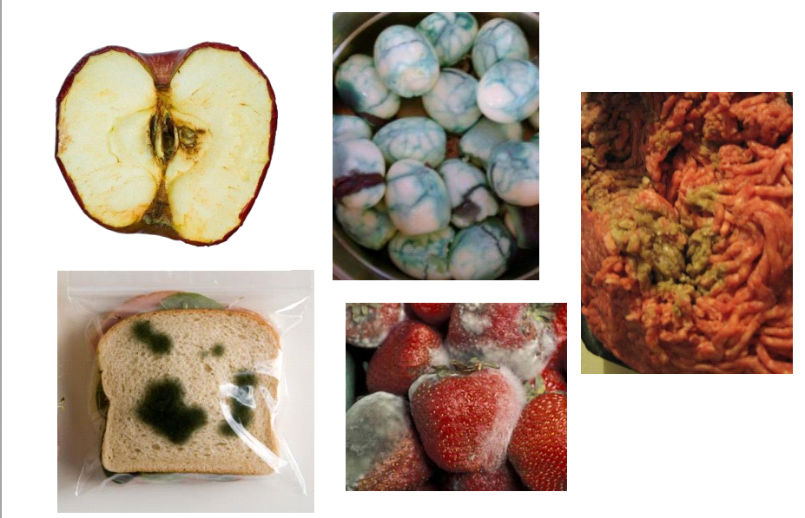

Fig 1.3.1: Food Deterioration In Warehouse.

.

**1.4 Proposed Solution:**

The system was divided into five parts:

a) The Data Management,

b) The Model Management System,

c) The Knowledge Engine,

d) The user interface, and

e) The user.

This system will be capable to report on the following functions:

1. Materials Traceability which Includes: sources, quantities, quality, Dates, Names, prices, packages types, numbers etc.

2. Storing status and the quality report which includes: quantities, quality types, dates and offers etc.

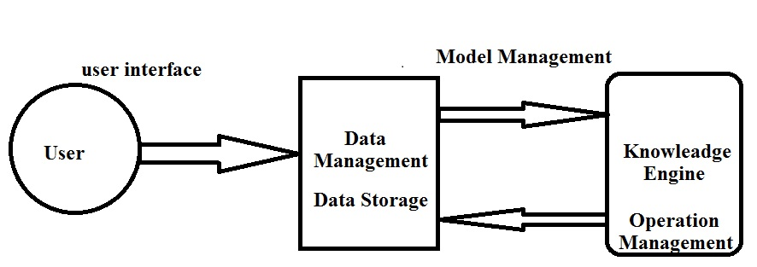

Fig. 1.4.1 System model

**1.5 Scope of the project:**

The System manages the storage environment of a food warehouse and enables management to arrange appropriate resources to be available for handling the warehouse operation. The system integrates RFID technologies, and a rule-based engine.

The system architecture is composed of 3 tiers:

**1) Data Capturing:**

Here, RFID technology is utilized in this system for capturing real-time environmental and operational data. It helps indicate the status of the food warehouse. Data is then transmitted to the database wirelessly.

**2) Data Storage**: In this tier, all data collected by the sensors and RFID arefirst decoded by middleware and then transferred to thedatabase for storage and further processing. The database,contains some pre-existing raw data related to the productand to warehouse resources, such as product nature, storagecondition, and date of delivery of order, order quality andSKU (Stock Keeping Unit) handling equipment.

**3) Operation Management***:* The facility allocation and stock picking system in this tier*,* is controlled by a rule-based engine, which is supported bythe database in tier 2. Inside the engine, different IF-THENrules are pre-defined according to the knowledge of foodwarehouse operations and food quality controls

**Chapter 2**

**Review of Literature**

Literature on Inventory Information in Food Industry is reviewed to demonstrate the importance of information In the Food Industry. Then, the existing approaches used for notification, and for assignment of facilities and its limitations are studied. After that, supportive information of Rule-based Decision Support System are suggested as ways of dealing with the problems.

**A. Inventory information in the Food Industry**

Information is a valuable resource of operations and inventory information is important for managers who need to arrange the warehouse operations efficiently. Inventory information is defined as records of the number of product categories, sources, lots size, Stock Keeping Unit , status of goods, etc[1]. This information acts as a foundation for the management to undertake daily planning strategies. At the same time, it is essential to use inventory information to support warehouse daily operations. The products of Food Industry can easily deteriorate and perishable goods have a comparatively short life span.[2] Hence, there is a huge demand for a quick response and for speed in the supply chain. In the Food warehouse, inventory information is needed throughout the whole duration of operations so as to minimize the inventory loss caused by deterioration.[2] When goods are in-bound or out-bound to the food warehouse, goods are usually allocated to or picked –up from different zones of the warehouse. The location allocated or the lots of goods picked are mainly decided and arranged according to the status of the Stock Keeping Unit. of the goods, the expiry date, the delivery date, etc.[1] All of these are items of inventory information. Therefore, in the case of improper management of information, it might not be possible to assign goods to the most optimal storage location. As a result, if the "first in first out" rule is broken because of the mishandling of inventory information, those products with limited time spans would turn bad or become obsolete. Once an improper decision is made, inventory loss will occur and the company suffers from loss in terms of good will, reputation and in money. Hence, the real-time status of goods is part of the inventory information needed for managing foods, especially food which can easily deteriorate.[2]

**B. Information Management System in Food Industry**

With the help of information technology, stock management has become easier than before different types of information can now be gathered in a more convenient manner. Companies are keen to access product order information, improve management of goods inventory [3], and improve the flow of information [2], especially in the Food Industry. However, even if companies have gathered critical data for managing inventories, few companies have an effective system to monitor the information on a real-time basis [5]. In order to obtain an efficient and effective food supply chain, the availability of real-time information system is essential. However, only a small proportion of companies have implemented technologies to manage inventory instantaneously [2]. Information technology vendors pointed out that, many of the companies have failed to integrate their newly implemented technology like information systems, with the existing operational processes [6]. This means that companies may have applied technologies in the warehouse, but they have failed to manage information in a way that is compatible with the existing warehouse operations procedures. The above situation would probably diminish the benefits of the implementation. Fortunately, if there is a proper information utilization and management approach, the positive effects of implementing technology into food warehouse can be amplified. Hence, if real-time food inventory information captured by the technology tools can be transmitted to the corresponding inventory allocation decision making process instantaneously, the operations of inventory allocation can be performed in a more fruitful way. Therefore, deterioration of food and stock that has time expired may be minimized. Before looking into the proposed solution, studies on the existing methods for handling inventory were studied.

**C. Existing method for notification, and assignment of Facilities**

The existing notification of variance and the assignment of facilities mainly rely on manual inspection which involves human beings for variance checking However; it is rare that any real-time notification mechanism is found in the food industry. In fact, any abnormal storage condition should be rectified immediately in order to stop food from deteriorating

However, the current phenomenon is that, whenever variation quantities of deteriorated or expired stock, faced by warehouse manager cannot be solved by these traditional methods. Hence, an inventory information management system capable of providing a real-time checking ability for visualizing the inventory status and for handling the food deterioration problems is urgently needed.

**D. Radio Frequency Identification (RFID) and Rule-based Decision Support System**

Radio Frequency Identification (RFID) is an auto-ID technology using radio waves for data transmission [4] that is widely used in the logistics sector. RFID system contains a wireless microchip and an antenna in the tag [1]. It does not require physical contact or line of sight positioning with the reader for data capturing, so it can be used to improve the physical handling time needed for product identification. The implementation of RFID can help supply chain parties to increase the visibility of inventory in terms of location and

stock levels as it provides real-time data about the status of inventory [1]. Hence, it improves efficiency in receiving and shipping goods. From the literature it can be seen that RFID has been adopted in the Food Industry for improving food traceability [5, 6]. It helps record and provides information to Food Industry operators throughout the manufacturing and distribution periods. With a RFID tag attached to individual food items of a pallet of food products, every movement can be traced besides accessing the physical traceability of goods. This study integrates different elements with the RFID system, so as to better utilize the information and ally those technologies with the warehouse operation. The Decision Support System (DSS) is one of the information system applications that can assist the decision making process of management by providing in-time and efficient solutions [5]. DSS provides a user friendly interface to the non-technical decision makers so they can construct management solutions in the shortest timeframe. Its construction is based on the relationship between the existing data, the scenario and the management solution.

**Chapter 3**

**SYSTEM ANALYSIS**

**3.1 Functional Requirements**

Functional requirements define the fundamental actions that system must perform.

The functional requirements for the system are divided into three main categories

**1) Data Capturing:**

Here, RFID technology is utilized in this system for capturing real-time information and operational data. It helps indicate the status of the food warehouse. Data is then transmitted to the database wirelessly.

**2) Data Storage**: In this section, all data collected by the sensors and RFID arefirst decoded by middleware and then transferred to thedatabase for storage and further processing.

The database,contains some pre-existing raw data related to the productand to warehouse resources, such as product nature, storagecondition, and date of delivery of order, order quality andSKU (Stock Keeping Unit) handling equipment.

**3) Operation Management***:* this sectionis controlled by a rule-based engine, which is supported bythe database in tier 2. Inside the engine, different IF-THENrules are pre-defined according to the knowledge of foodwarehouse operations and food quality controls

**3.2 Non Functional Requirements**

## Safety Requirements:

Safety has to be considered while implementation of application because there may possibility of fake tracing RFID tag information from the food product in the database.

**Security Requirements**

The manager will require various food credentials such as food Quantity, food stock, and product information etc.

**Performance**

The ability to remove the traditional based failures and provides satisfying results.

* Easy to use
* User Friendly
* Scalable
* Innovative

**3.3 Specific Requirements:**

Front end: java and JSP

Back end-My SQL

Microsoft SQL Server is relational database server developed by Microsoft. It Support for structured and semi-structured dada, including digital media format for picture , audio , video and other multimedia data . SQL server 2008 can be a data storage backend for different varieties of data: XML, email, document etc.

**Hardware Requirement**

* RFID (Radio Frequency Identification )
* RFID Tag.
* Intel Processors
* Memory space Maximum 512 MB

**Software Requirement**

* Support Windows XP/2007/2008 and Linux
* Java 1.6
* Java Script.
* Microsoft SQL Server 2005/2008

**3.3 Specific Requirements**

**Identification of Food product:**

The food products of the Warehouse System is Identified By the Application.

**Domain Constraint:**

The Software and their functionality will be limited for particular location area into consideration.

**Methods:**

A huge amount of data is present but the data has to be presented in a format that can be used for strategic decision making and provides a means for analyzing trends.

**3.4 Use-Case Diagrams and description:**

**Use Case Diagram :**

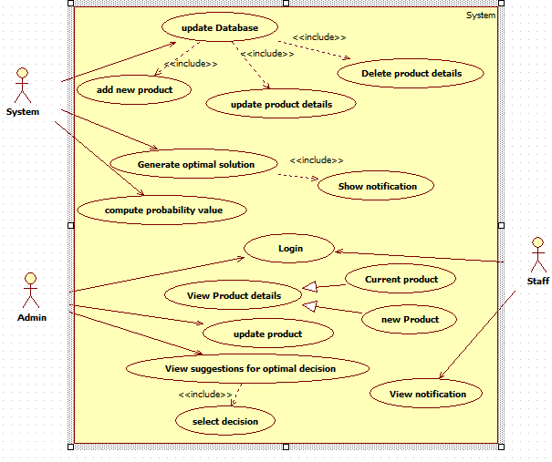

Fig 3.4 .1 Use case Diagram for DSS for food industry

Table 3.3.1 Use case description for update Database

|  |  |
| --- | --- |
| Use Case Name | Updating Database |
| Actors | System , Admin |
| Pre-condition | Admin updates/deletes current Product details or add new product details. |
| Post-condition | The system will save the changes made in the database. |
| Scenario. | 1. Manager selects from options to add/update/delete Product details.  2. Enters the required data of product.  3.System will update the database accordingly. |

Table 3.3.2 Use case description for viewing Optimal Plans

|  |  |
| --- | --- |
| Use Case Name | Viewing Optimal Decision |
| Actors | System , Admin |
| Pre-condition | Admin Will Select the plan and factor based on which suggestion would be generated. |
| Post-condition | Graphical representation of the statistics of food Product based on plans and factors. |
| Scenario. | 1. Admin selects the plan for which Notification are needed.  2. Then he select the factor based on which Notification are to be generated.  3. System graphically display the current scenario of the food products. Using the given plan and factor.  4.System will generates Notification for the given plan and factor. |

**Chapter 4**

**ANALYSIS MODELING**

**4.1 Data Modeling:**

E-R Model:

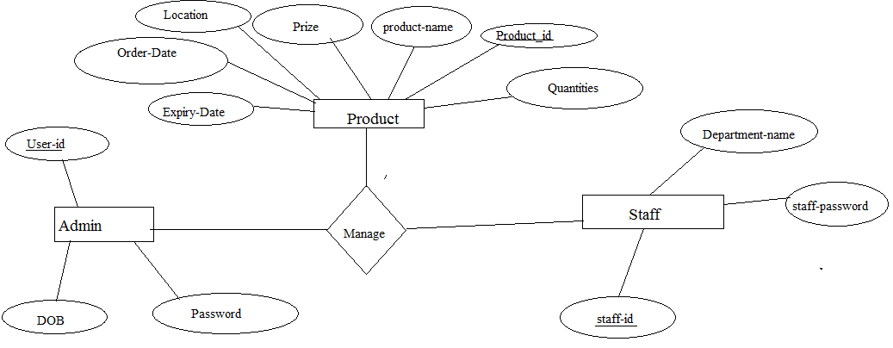

Fig. 4.1.1 ER Diagram

ER Diagram normalization:

4.1.1. Product Table

|  |  |  |  |  |  |  |
| --- | --- | --- | --- | --- | --- | --- |
| Product-id | Product-name | Quantities | Prize | Location | Order-Date | Expiry-Date |

4.1.2. Admin Table

|  |  |  |
| --- | --- | --- |
| User-id | Password | DOB |

4.1.3. Staff Table

|  |  |  |
| --- | --- | --- |
| Staff-id | Password | Depart-name |

**Data Dictionary:**

Table 4.1.4 Current product table.

|  |  |  |  |
| --- | --- | --- | --- |
| Name of the attribute | Data types | Key | Description |
| Product _id | Number(10) | Primary key | All foods are uniquely identified |
| Product-name | Varchar2(20) | Not null | Name of the product |
| Quantities | Number(20) |  | Quantities of foods |
| Prize | Number(20) |  | Prize of the foods |
| Location | Varchar2(20) |  | Location of product |
| Order-date | Date |  |  |
| Expiry-date | Date |  | Expiry date of the product |

Table 4.1.5 Admin table.

|  |  |  |  |
| --- | --- | --- | --- |
| Name of the attribute | Data types | Key | Description |
| User- id | Number(10) | Primary key | User id for the Admin. |
| Password | Varchar2(20) | Not null | Password for the admin. |
| DOB | Date |  | Date of birth of admin. |

Table 4.1.6 Staff table.

|  |  |  |  |
| --- | --- | --- | --- |
| Name of the attribute | Data types | Key | Description |
| staff- id | Number(10) | Primary key | User id for the staff. |
| Password | Varchar2(20) | Not null | Password for the staff. |
| Depart-name | Varchar2(20) |  | Department name of the admin. |

**4.2 Activity Diagrams:**

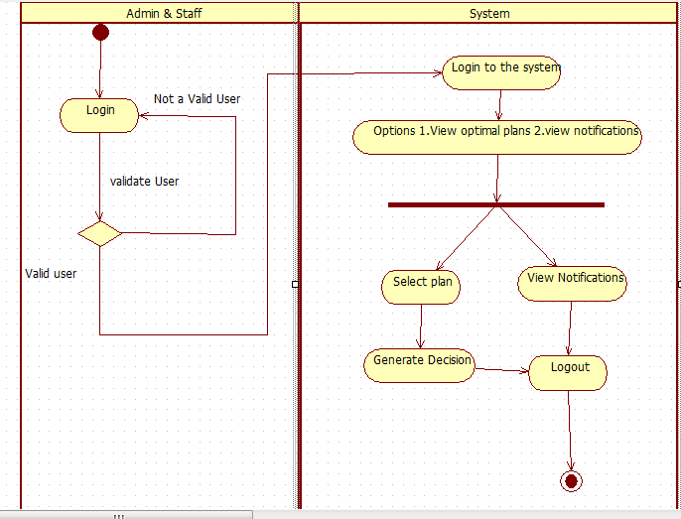

Fig. 4.2.1 Activity diagram

**4.3 Functional Modeling:**

Data flow diagram :

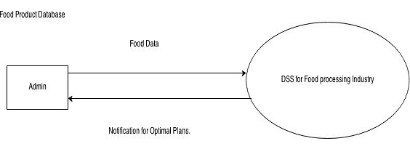

Fig. 4.3.1. Data flow Diagram for DSS

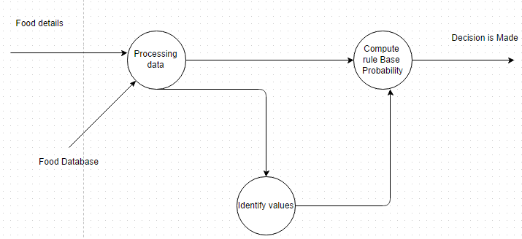

Fig. 4.3.2. Data flow Diagram for Estimating Probability of Food .

**4.4 TimeLine Chart**

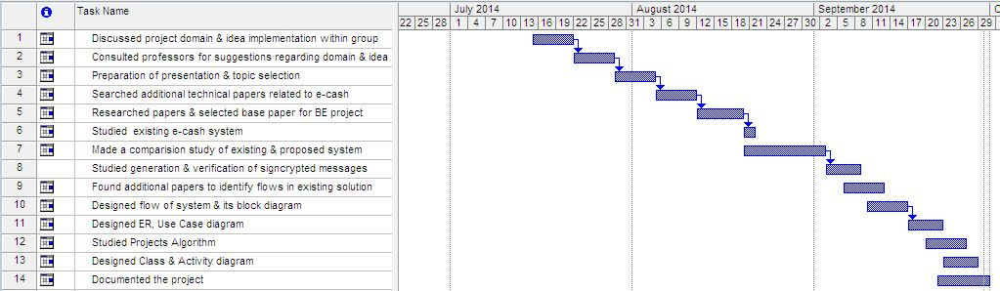

Fig 4.4.1 TimeLine chart

**Chapter 5**

**DESIGN**

**5.1.1 Architectural Design:**

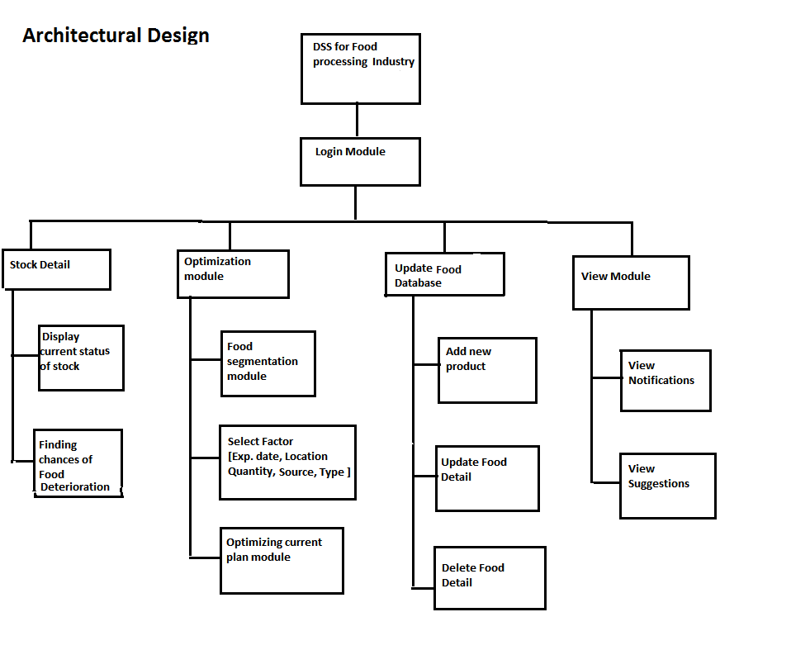

Fig. no 5.1.1 Architectural Design

**Login module*:***

|  |  |
| --- | --- |
| Module Name | Login Module |
| Input Given | Username , Password |
| Output Obtained | Login Verification |
| Procedure/steps | 1. Login ID is entered. 2. Password is entered. 3. If the User ID & Password match, the Login is accepted |

**Stock Detail:**

|  |  |
| --- | --- |
| Module Name | Stock Detail |
| Input Given | The product ,Ordered in large scale from Indutries. |
| Output Obtained | Display the record of products . |
| Procedure/steps | 1. Enter the Details of product. 2. Chances of product need to be ordered are displayed. |

**Optimization Module:**

|  |  |
| --- | --- |
| Module Name | Optimization Module |
| Input Given | Current Food Database. |
| Output Obtained | Optimal Suggestion plan |
| Procedure/steps | 1. Select the factor of suggestion of plan. 2. The system calculate the optimal plan. |

**5.2 User Interface Design:**

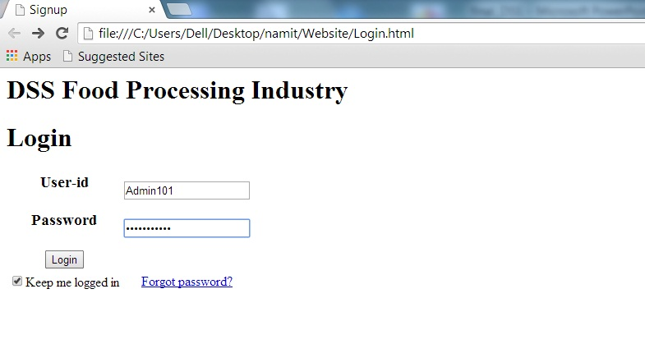

Fig 5.2.1 Login page

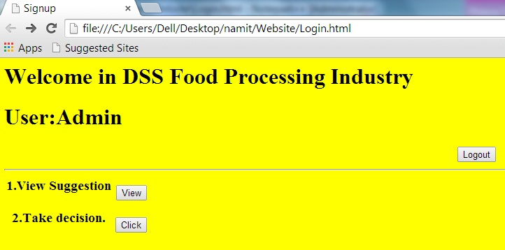

Fig 5.2.2 Admin page.

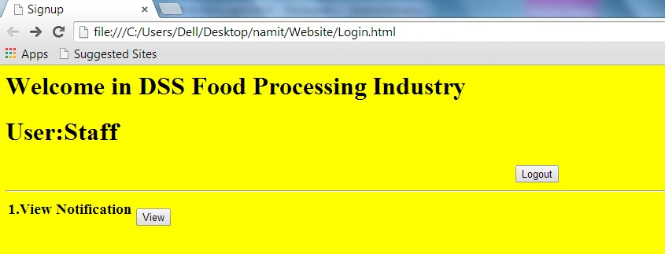

Fig. 5.2.3 Staff page.

**Chapter 6**

**IMPLEMENTATION**

**6.1 Working of the project:**

This system will be capable to report on the following functions:

1. Materials Traceability which Includes: sources, quantities, quality, Dates, Names, prices, packages types, numbers etc.

The Material traceability is Implement with the help of RFID Device.

The RFID(Radio frequency Identification ) is an auto-ID technology using radio waves for the data transmission . RFID system contains a wireless microchip and an antenna in the tag It does not require physical contact or line of sight positioning with the reader for data capturing, so it can be used to improve the physical handling time needed for product identification. The implementation of RFID can help supply chain parties to increase the visibility of inventory in terms of location and stock levels as it provides real-time data about the status of inventory.

2. Storing status and the quality report which includes: quantities, quality types, dates and offers etc.

The system will generate following types of Decisions:

1. It Determines the Quality of the product.
2. Wastage of foods in food warehouse.
3. It Display the available Food Stocks in the food Warehouse

4) Location of the degraded foods.

The following suggestion is display for the staff

1. Location of the degraded foods.
2. Available food in food warehouse.
3. Wastage of foods in food warehouse.

Algorithm:

k-means clustering:

* The clustering is utilized to segment food product
* Firstly the food is clustered according to their Quality status
* As the result the 3 clustered will detected.
* Then each cluster is internally clustered according to three demographic

Variable Quantity ,prize , sales and location.

Baye's Theorem :

* Bayesian classifier are able to predict class membership probabilities such as the probability that a given tuple belongs to a particular class.
* This is applied on the sets of cluster to predict the Quality of the foods.
* Based on the Prediction final decision will made.

.

**Chapter 7**

**Conclusions**

This System is proposed to enhance the inventory information capturing and management in food warehouses. The System uses RFID to gather real-time inventory information regarding the warehouse, and links this information to the decision making process of the manager. The process is supported by a rule-based engine. By the use of this inventory information management system, inventory information can be related to the warehouse operation, and the operation time needed is shortened. Besides, control of food quality becomes much easier than before.

**Appendix**

**8.1 k-means clustering algorithm**

k-means is one of the simplest unsupervised learning algorithms that solve the well known clustering problem. The procedure follows a simple and easy way to classify a given data set through a certain number of clusters (assume k clusters) fixed apriori. The main idea is to define k centers, one for each cluster. These centers should be placed in a cunning way because of different location causes different result. So, the better choice is to place them as much as possible far away from each other. The next step is to take each point belonging to a given data set and associate it to the nearest center. When no point is pending, the first step is completed and an early group age is done. At this point we need to re-calculate k new centroids as barycenter of the clusters resulting from the previous step. After we have these k new centroids, a new binding has to be done between the same data set points and the nearest new center.

A loop has been generated. As a result of this loop we may notice that the k centers change their location step by step until no more changes are done or in other words centers do not move any more. Finally, this algorithm aims at minimizing an objective function know as squared error function given by:

[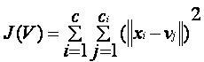](https://sites.google.com/site/dataclusteringalgorithms/k-means-clustering-algorithm/kmeans.JPG?attredirects=0)

|  |
| --- |
| where,                            *‘||xi- vj||’* is the Euclidean distance between *xi* and *vj.*  *‘ci’* is the number of data points in *ith* cluster.  *‘c’* is the number of cluster centers. |

**Algorithmic steps for k-means clustering**

Let  X = {x1,x2,x3,……..,xn} be the set of data points and V = {v1,v2,…….,vc} be the set of centers.

1) Randomly select *‘c’* cluster centers.

2) Calculate the distance between each data point and cluster centers.

3) Assign the data point to the cluster center whose distance from the cluster center is minimum of all the cluster centers..

4) Recalculate the new cluster center using:

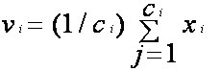

where,*‘ci’* represents the number of data points in *ith* cluster.

5) Recalculate the distance between each data point and new obtained cluster centers.

6) If no data point was reassigned then stop, otherwise repeat from step 3).

**8.2 2-phase K-means algorithm**:

* A two phase clustering is utilize to segment food products.
* Firstly food were clustered according to their Quality.
* As the result , 5 clusters will be detected
* Then each cluster is internally clustered according to three demographic

Variable Quantity , prize, sale and location.

**8.3 Baye's Theorem**

Bayesian classification is based on Baye's Theorem. Bayesian classifiers are the statistical classifiers. Bayesian classifier are able to predict class membership probabilities such as the probability that a given tuple belongs to a particular class.

The Naive Bayesian classifier is based on Bayes’ theorem with independence assumptions between predictors. A Naive Bayesian model is easy to build, with no complicated iterative parameter estimation which makes it particularly useful for very large datasets. Despite its simplicity, the Naive Bayesian classifier often does surprisingly well and is widely used because it often outperforms more sophisticated classification methods.

**Theorem:**

Bayes theorem provides a way of calculating the posterior probability, *P*(*c|x*), from *P*(*c*), *P*(*x*), and *P*(*x|c*). Naive Bayes classifier assume that the effect of the value of a predictor (*x*) on a given class (*c*) is independent of the values of other predictors. This assumption is called class conditional independence.

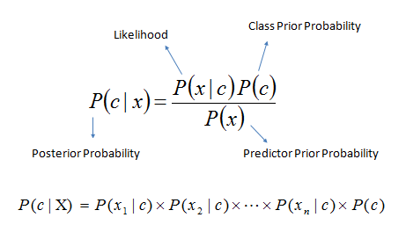

* *P*(*c|x*) is the posterior probability of *class* (*target*) given *predictor* (*attribute*).
* *P*(*c*) is the prior probability of *class*.
* *P*(*x|c*) is the likelihood which is the probability of *predictor* given *class*.
* *P*(*x*) is the prior probability of *predictor*.

**Literature Cited**

* IEEE References

[1] An Integrative Food Handling System for Managing Inventory Information in Food Warehouses. S. I. Lao, K. L. Choy, Y. C. Tsim, S.K. Kwok, T.C. Poon Dept of Industrial and Systems Engineering, The Hong Kong Polytechnic University, Hong Kong

* Book

[2] Data Mining and Warehousing by S. Prabhu Publisher : New Age International, 2007

* Journal Paper

[3] Abad, E., Palacio F., Nuin, M., Zarate, G.A., Juarrros, A., Gomex, J.M.,

and Marco, S., "RFID smart tag for traceability and cold chain monitoring of foods: Demonstration in an international fresh logistic chain", Journal of Food Engineering, 93, pp. 394- 399, 2009.

[4] Achour, M., "A new method to assess the quality degradation of food products during storage", Journal of Food Engineering, 75, pp. 560- 564, 2006.

[5] Becker, B.R., "Food thermo physical property models", International Communications in Heat and Mass Transfer, 26(5), pp. 627- 636, 1999.

[6] Chow, K.H., Choy, K.L., Lee, W.B., and Chan, F.T.S., "Integration of web-based and RFID technology in visualizing logistics operations – A case study", Supply Chain Management: An International Journal, 12(3), pp. 221- 234, 2007

**Acknowledgements**

We would like to thank St. Francis Institute of Technology for providing us with excellent resource to carry out this Project and make it successful. We would like to thank our Project guider Mrs. Bidisha Roy for their guidance and for sharing there valuable inputs with us. We would like to thank our External guider Mrs. Versha Nagpurkar for their guidance and support.

We would like to thank for all the documentation related support from our colleagues and lab assistants for helping us as per our needs. Finally, we extend our thanks and gratitude to our family and friends for providing us support needed to complete this project.

1.---------------------------------------------

2.---------------------------------------------

vi

**List of Figures**

|  |  |  |
| --- | --- | --- |
| **Fig. No.** | **Figure Caption** | **Page No.** |
| 1.3.1 | **Food Deterioration In Warehouse** |  |
| 1.4.1 | **System model** |  |
| 3.4.1 | **Use case Diagram for DSS for food industry** |  |
| 4.1.1 | **ER Diagram** |  |
| 4.2.1 | **Activity diagram** |  |
| 4.3.1 | **Data flow Diagram for DSS** |  |
| 4.3.2 | **Data flow Diagram for Estimating Probability of Food .** |  |
| 4.4.1 | **TimeLine chart** |  |
| 5.1.1 | **Architectural Design** |  |

vii

**List of Tables**

|  |  |  |
| --- | --- | --- |
| **Table No.** | **Table Title** | **Page No.** |
| 3.3.1 | **Use case description for update Database** |  |
| 3.3.2 | **Use case description for viewing Optimal Plans** |  |
| 4.1.1 | **Product Table** |  |
| 4.1.2 | **Admin Table** |  |
| 4.1.3 | **Staff Table** |  |
| 4.1.4 | **Current product table** |  |
| 4.1.5 | **Admin table** |  |
| 4.1.6 | **staff table** |  |

viii

**List of Abbreviations**

|  |  |  |
| --- | --- | --- |
| **Sr. No.** | **Abbreviation** | **Expanded form** |
| 1 | DSS | Decision Support System |
| 2 | RFID | Radio frequency Identification |
| 3 | IFHS | Integrative food handling system |
| 4 | SKU | Soft keeping Unit |
| 5 | DFD | Data flow diagram |

ix